APPROVAL REQUEST
What
An Approval Request related list will be configured on the Database Tables / Network Database record.
This allows users and administrators to view approval records associated with a particular network database/request directly from its form.
The configuration consists of:
- Creating an Approval Request relationship.
- Adding the resulting related list to the Network Database form.
Why
Approval information is an important part of the network request lifecycle. By displaying approval records directly on the Network Database form:
- Approvers can be associated with the appropriate request.
- Approval status can be monitored from the request record.
- Administrators can easily track approval activity.
- The request and its approval information remain connected.
- The solution provides better traceability and audit visibility.

Activity 1 – Creation of Related List Relationship
What
Create a ServiceNow Relationship that connects records in the Network Database table with records from the sys approval table.
How
- Navigate to:
All → System Definition → Relationships
- Click New.
- Enter the relationship details:
Field | Value
Name | Approval Request
Applies to table | Database Tables
Queries from table | sysapproval / approval table specified by the lab
Active | True
- Review the relationship configuration.
- Click Submit or Save.
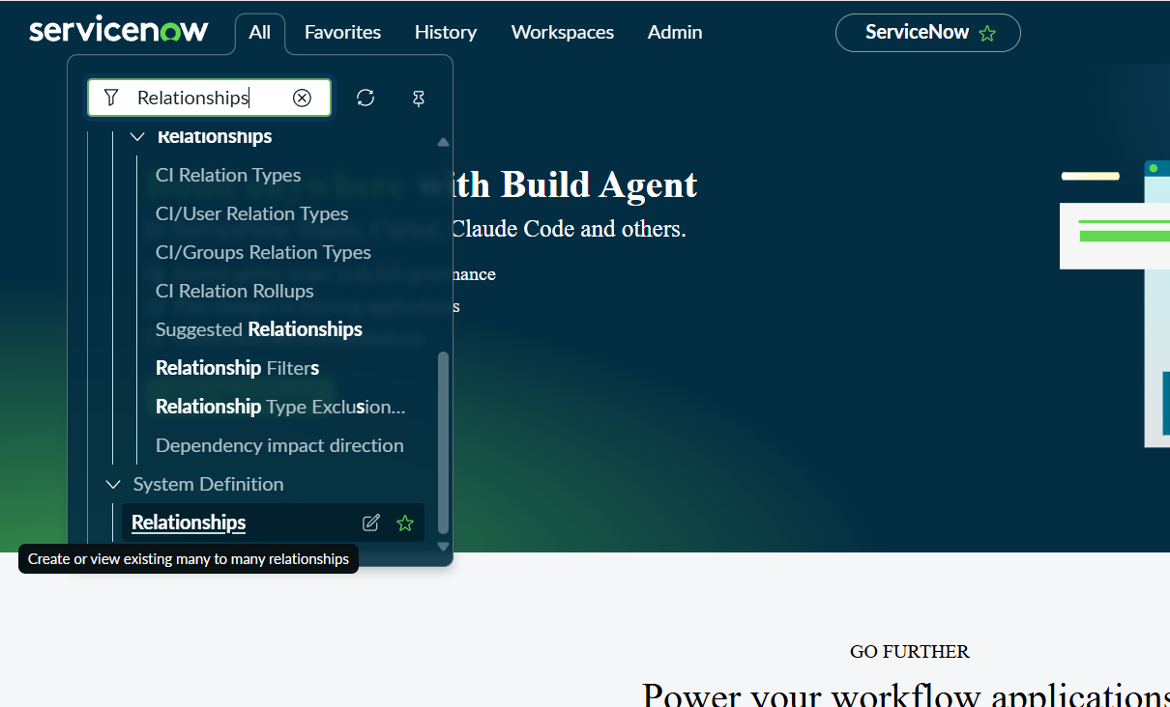
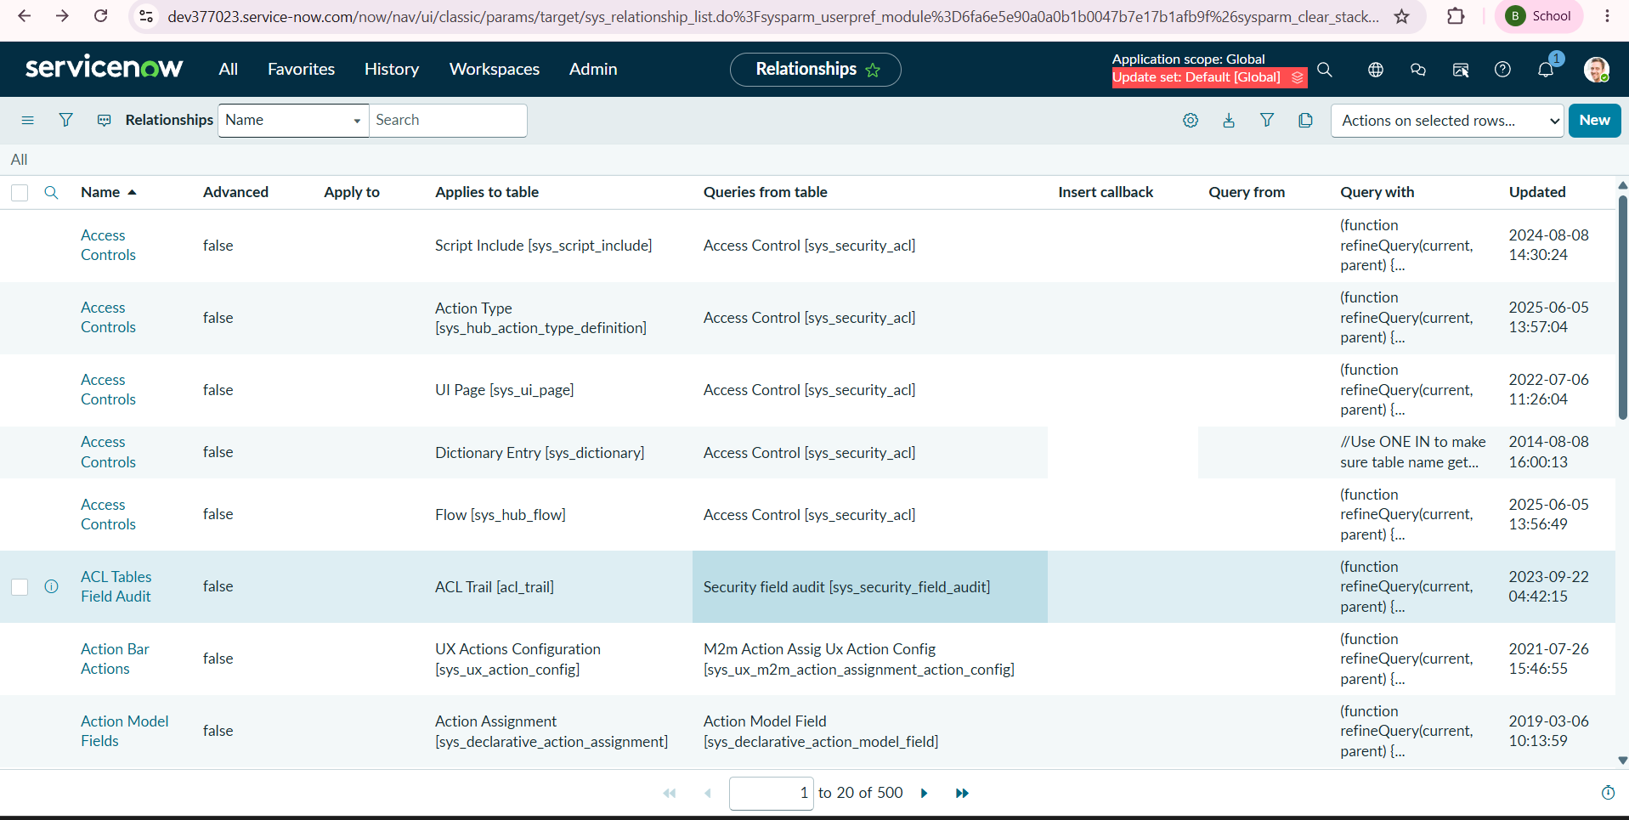
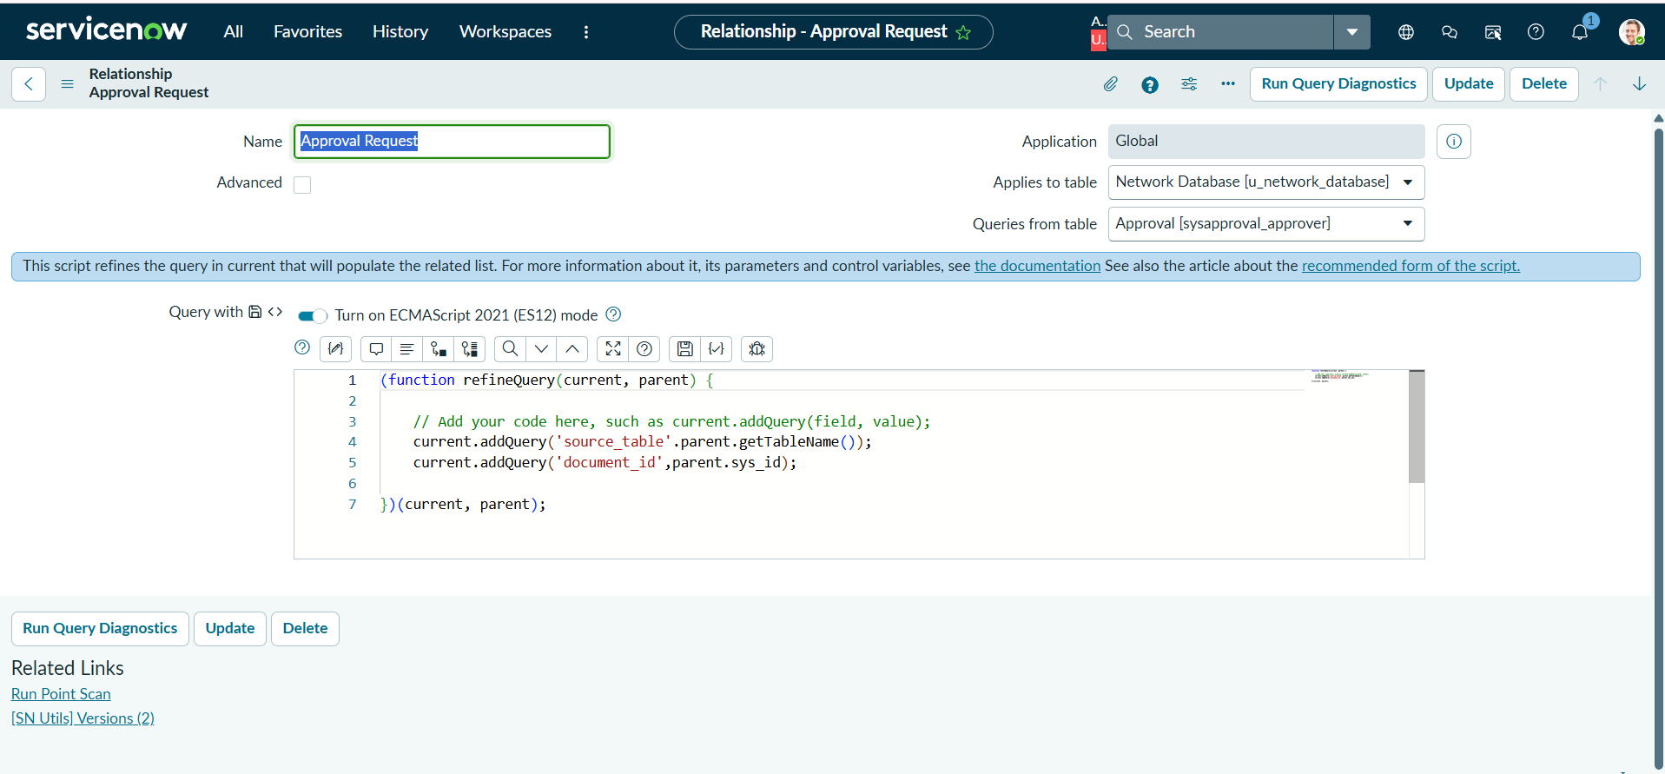

Outcome
The Approval Request relationship is created and can now be used to display related approval records on the Network Database form

Activity 2 – Add Approval Related List to the Form
What
Add the approval-related list to the Network Database form so that users can see associated approval records directly from the record.
Why
Displaying approvals on the same form provides a centralized view of the request and its approval information, reducing the need to navigate to another table.
How
- Navigate to the Database Tables / Network Database table.
- Open an appropriate Network Database record.
- Open the form configuration/design interface.
- Locate the Related Lists section.
- Add the Approval Request related list.
- Arrange the related list in the desired position.
- Save the form configuration.
- Reopen the Network Database record.
- Scroll to the related-list section.
- Verify that Approval Request is displayed.
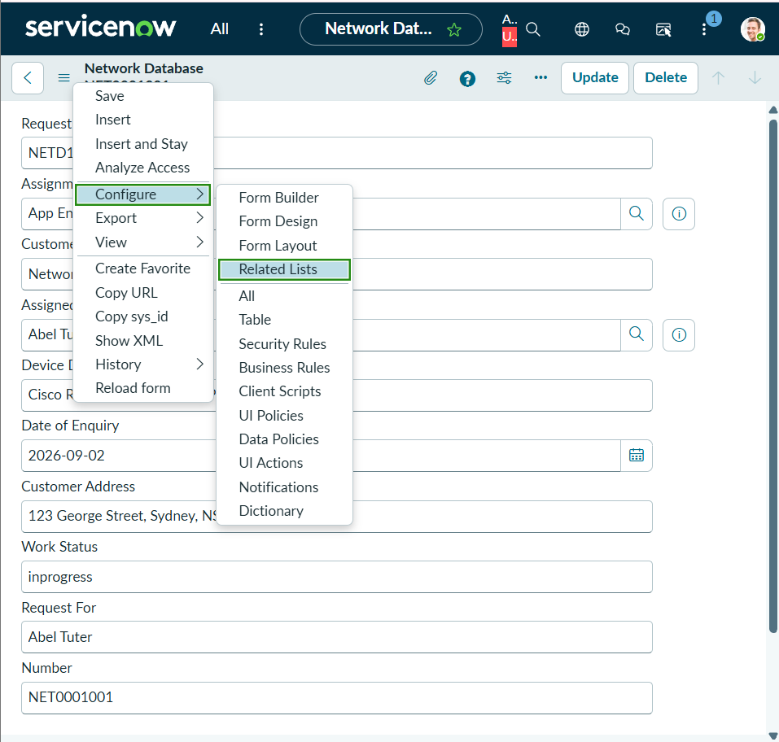

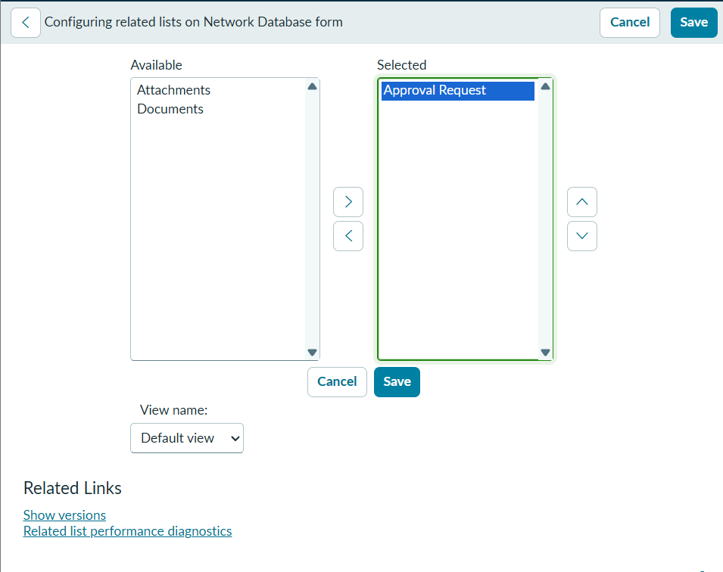
Validation
Create or use a Network Database record that goes through an approval process.
Verify that:
- The Network Database record opens successfully.
- The Approval Request related list is visible.
- Associated approval information appears in the related list when an approval record exists.
- The approval information is associated with the correct request.
Expected Result
Network Database Record
│
├── Request Information
│
├── Assignment Information
│
├── Connection Information
│
├── Approval Status
│
└── Approval Request
│
└── Related Approval Record
Outcome
The Network Database form now provides a centralized view of its associated approval information. This improves approval visibility, traceability, and operational monitoring throughout the request lifecycle.
Important Configuration Note
Your instructions say sysapprovals, while ServiceNow environments commonly use approval-related tables such as sysapproval_approver. Follow the exact table specified by your capstone instance/instructions, rather than changing it based on a generic ServiceNow setup.
Also, your instruction says “configure the approvals on Network Database table.” This means don't stop after creating the relationship—the final evidence should show the Approval Request related list actually visible on a Network Database record.

